**User Guide**

360-Degree Photography Project

*April 2019*

*Version 0.1*

|  |  |  |
| --- | --- | --- |
| Date | Version Number | Document Changes |
| 4/8/2019 | 0.1 | Initial Draft |
|  |  |  |
|  |  |  |

**Introduction** **3**

Scope and Purpose 3

Process Overview 3

**Product and Camera Placement** **4**

Product Setup 4

Aiming the Cameras 4

**Capturing Previews** **5**

**Starting a Full Capture** **7**

Entering Item ID 7

Full Capture 7

**Saving Photos to Storage** **10**

View Larger Images 10

Selecting Photos 10

Saving to Storage 10

**Troubleshooting** **13**

Missing Camera Error 13

Autofocus Error 13

Camera Error 13

Slow Camera Capture 13

# Introduction

## Scope and Purpose

This project is intended for for capturing a 360-degree view of a product. It allows a user to access a webpage as well as control hardware that captures images of the product(s). This solution has 3 main components, the Front End, the Communication Layer, and the Hardware Controller. The Front end allows the user to:

* Enter an Item ID for a specific product
* Capture a preview image of the product on the turntable
* Start a full 360-degree capture for the product
* Select the images to remove from the images taken
* Save images to Spreetail’s Azure Storage Blob
* Restart the 360-capture
* Cancel the Capture process

The Hardware Controller is a computer tower running software that controls two DSLR cameras connected via usb. The two cameras are powered by wired batteries and are aimed at the product at 2 different angles, straight on, and at an downward angle. The products will be placed on an electric turntable that spins at a constant rate.

This solution is intended to simplify the photo taking process for warehouse employees, providing them easy control and hardware to capture images. The purpose of this User Guide is to inform users of the processes and workflows and any other information regarding the use of this solution. It is assumed that the solution has been properly set up and that the user has knowledge of item IDs and photography.

## Process Overview

1. Product and Camera Placement
2. Capturing a Preview
3. Starting a Full Capture
4. Saving Photos to Storage
5. Troubleshooting

# 

# Product and Camera Placement

Setting up the product and aiming the cameras correctly is a very important part of the process. The product being photographed must fit on the turntable, and must not exceed 100 lbs. During each product change, the cameras must be re-focused for each product, as products will vary in size.

## Product Setup

1. Place the product onto the turntable
2. Ensure that product is in the center of the turntable
   1. Easy way to do this is to look down on the turntable to see where the product is placed
3. Continue to **Aiming the Cameras**

## Aiming the Cameras

1. Ensure that the camera is in an appropriate focus mode
   1. Focus mode is changed by small button near capture button (**Figure 1**)
   2. A recommended focus mode is shown in **(Figure 2**)
2. Move each tripod/camera to get a good view of the product
3. Ensure that the camera can focus on the product correctly
4. Once these steps are complete, continue to **Capturing Previews**

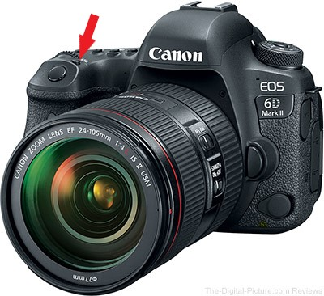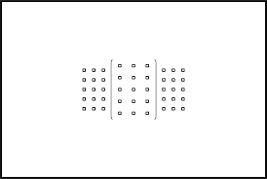

Figure 1. Figure 2.

[This step is very important! The focus of the camera on the product will affect the quality of the images as well as the camera's ability to correctly focus on the product throughout the rotation. Ensure that the camera is on the correct focus mode and that the camera is able to focus before continuing through the workflow!]

# Capturing Previews

Capturing preview images allow users to see example images of the products rotating to ensure that the images being taken by the cameras are of high quality.

1. Navigate to the Project Site
2. Click the “Preview” Button in the bottom left part of the page (Red outline in **Figure 3**)
3. Ensure that cameras captured image and that photos are displayed on page (**Figure 4**)
4. If images are blurry or product is not in middle of frame:
   1. Follow Steps under **Product Setup**
   2. Start from step 2 of this section
5. If images look good, continue to **Starting a Full Capture**

**[If you encounter any errors during the preview process, please refer to the TroubleShooting** section.**]**

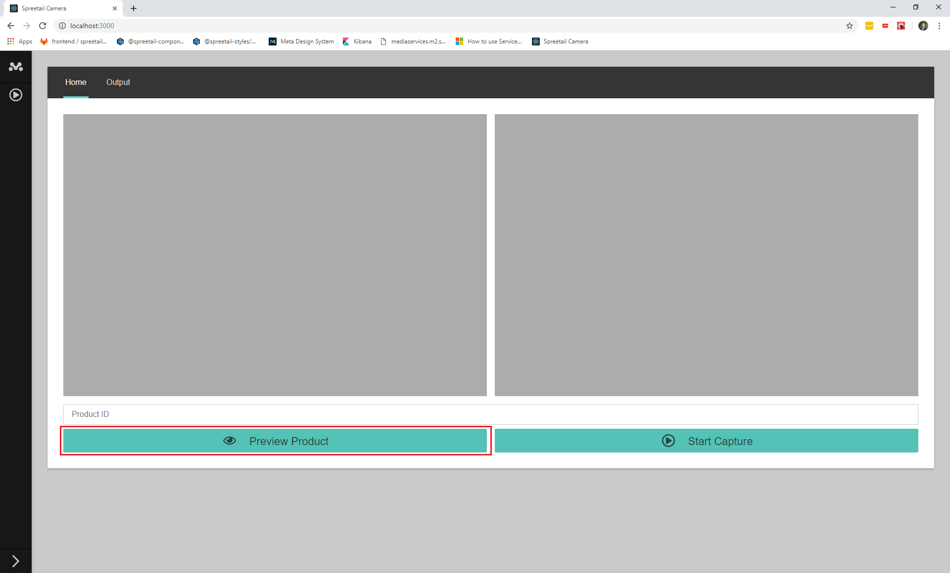

**Figure 3**

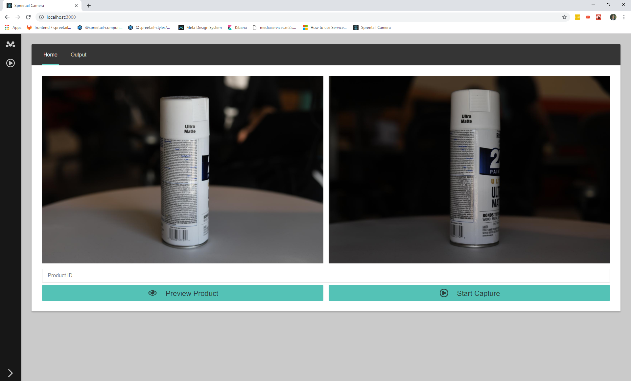

**Figure 4**

# 

# Starting a Full Capture

Starting a full capture means that the cameras will capture 1 full rotation-worth of images with respect to the turntable. To start a full capture, the product Item ID is required. The steps below describe the process of starting a full capture.

## Entering Item ID

1. If using a Barcode Scanner, make sure that the scanner is connected and can enter the scanned information as a keyboard
2. Enter the numeric item ID into the Item ID textbox under the preview images (Highlighted red in **Figure 5**)
3. Continue to **Full Capture**

## Full Capture

1. To start the full capture, click the “Start Capture” button in the bottom right part of the page (Highlighted red in **Figure 6**).
2. Wait for the full capture process to end. The process has been started and the user is directed to a new page. The user should see a progress bar that shows the current progress through the photo taking process. Images pop up as they are taken and sent to the front end. (**Figure 7**)
3. To cancel the process, click the “Cancel” button (Highlighted red in **Figure 8**) and continue at **Capturing Previews**
4. When the process ends, continue to **Saving Photos to Storage**

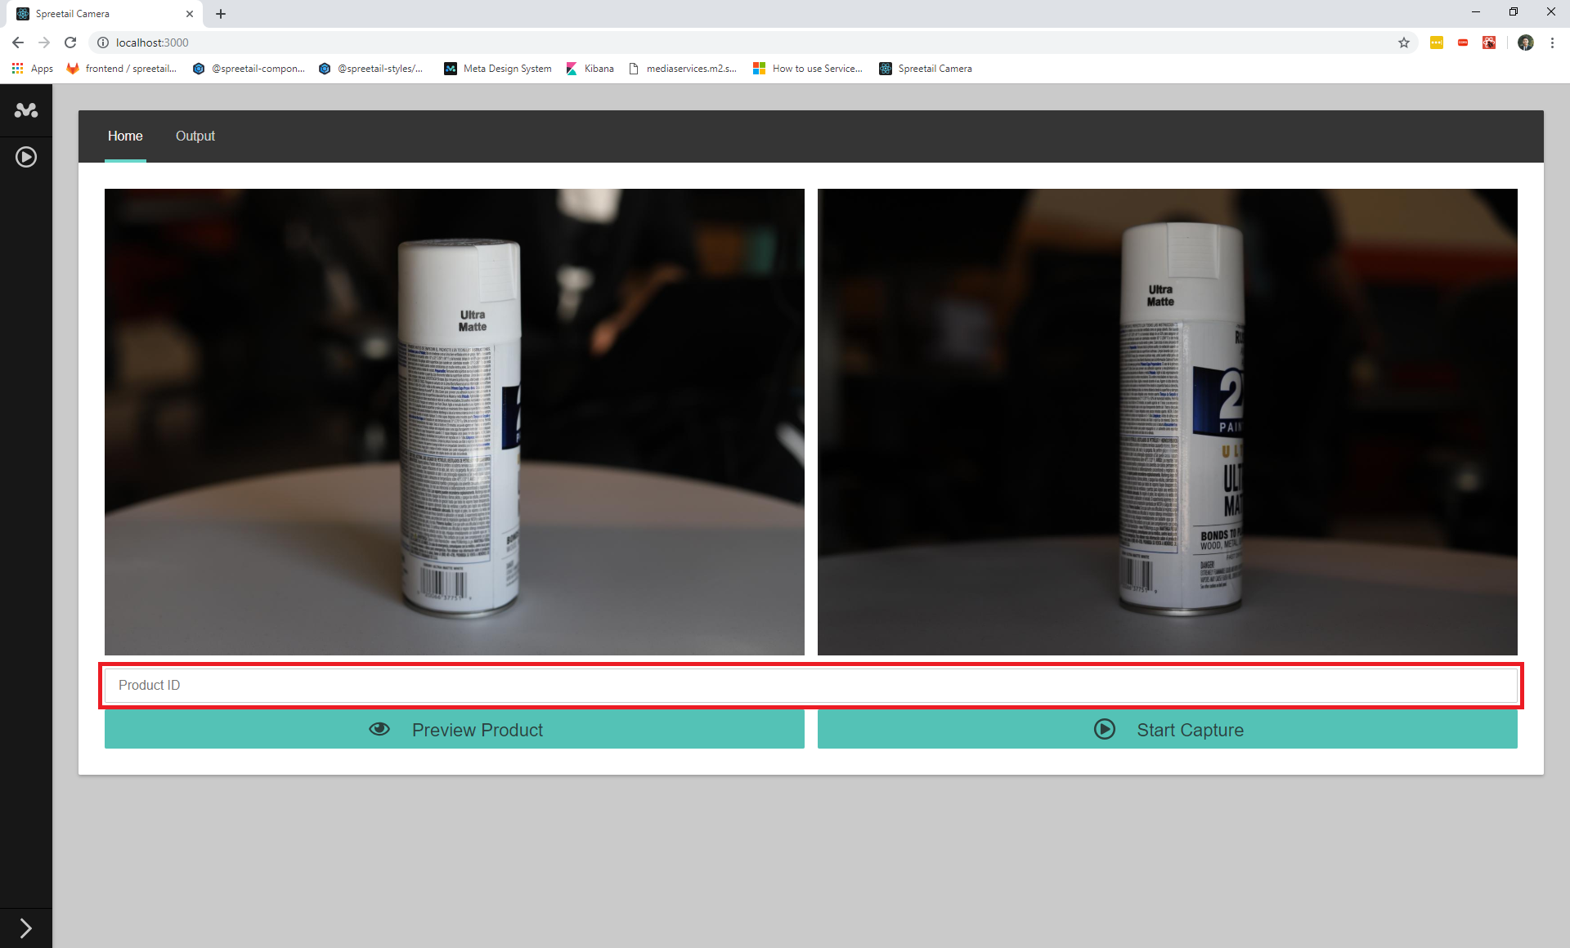

**Figure 5**

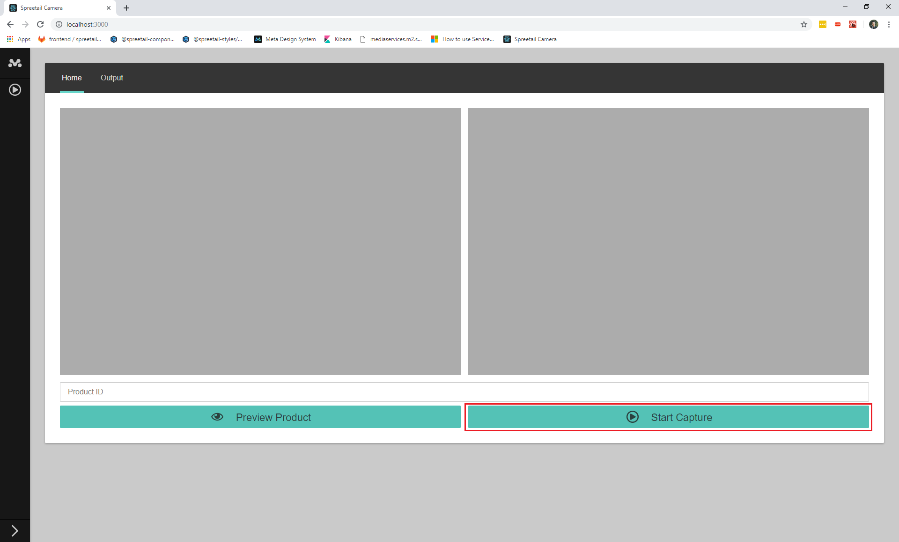

**Figure 6**

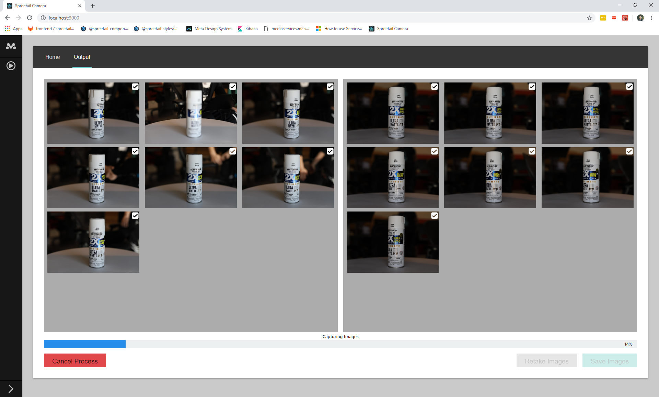

**Figure 7**

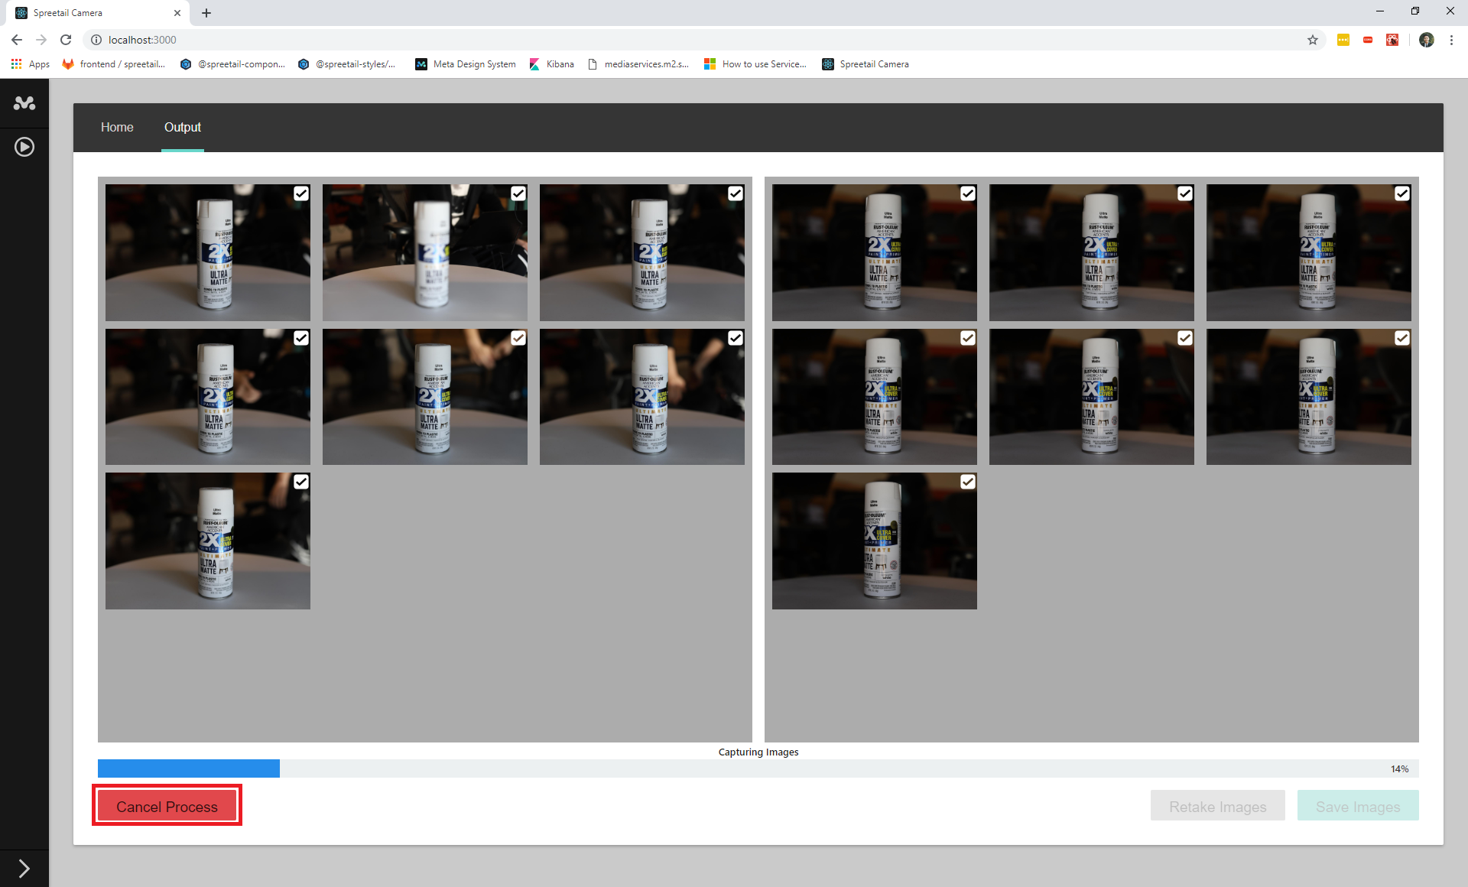

**Figure 8**

# Saving Photos to Storage

To save the photos, the user must look at a combination of the thumbnails provided as well as a larger view of the images if needed. The user should ensure that all of the images are of acceptable quality and that the correct images are selected to be saved. An images that are grayed out in the view will not be saved to Spreetail Storage. The photos are stored in Spreetail’s Azure Storage Blob, so there is no need for saving the photos locally.

## View Larger Images

1. To view a larger version of the images, click the middle of any image thumbnail, this will bring up a larger view of that image (**Figure 9**)
2. To move between photos, click the arrows on the side of the screen or use the arrow keys on the keyboard
3. To exit this view, click the small “x” above and to the right of the shown photo, or click anywhere outside of the photo viewer
4. Continue to **Selecting Photos**

## Selecting Photos

1. To remove a photo, click the small checkbox in the top right corner of the thumbnail, this ensures that this photo will not be stored (**Figure 10**)
2. To re-enable a photo, click the checkbox once more to add it to the files to be stored
3. If the photos look good and are ready to be saved:
   1. Continue to **Saving to Storage**
4. If the process needs to be repeated:
   1. Click the “Retake” button in the bottom right corner of the page (Highlighted red in **Figure 11**)
   2. Continue with **Capturing Previews**

## Saving to Storage

1. To save images to storage, click the “Save Images” button in the bottom right corner of the page (Highlighted red in **Figure 12**)
2. Restart to **Product Setup**

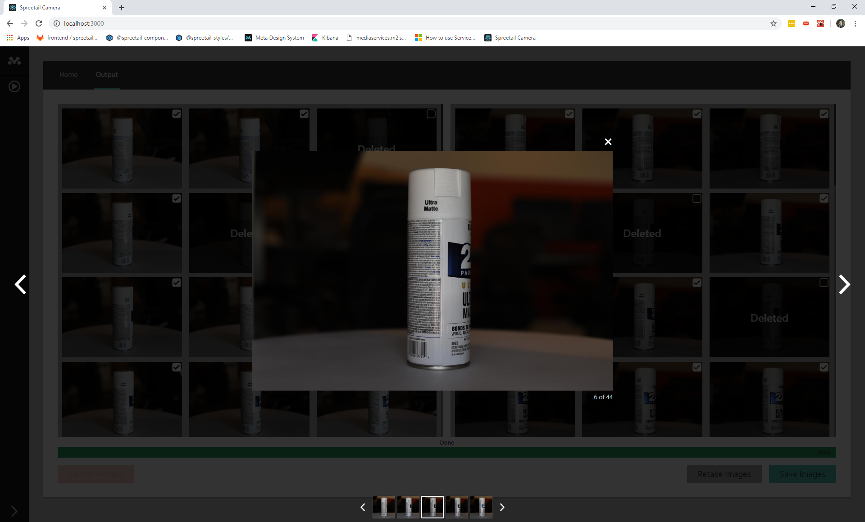

**Figure 9**

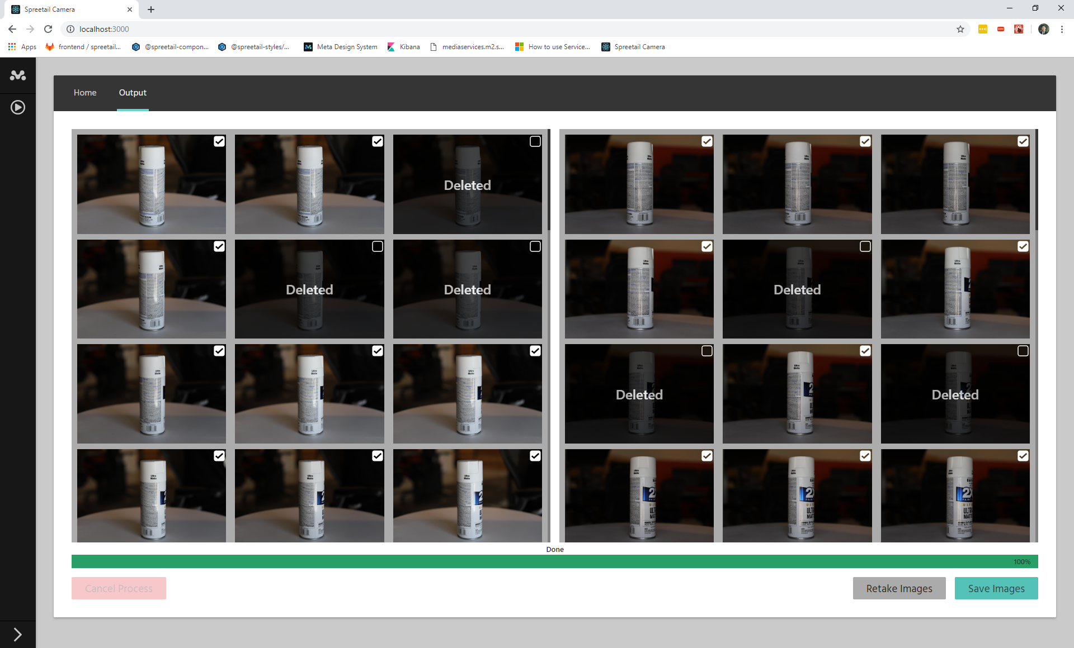

**Figure 10**

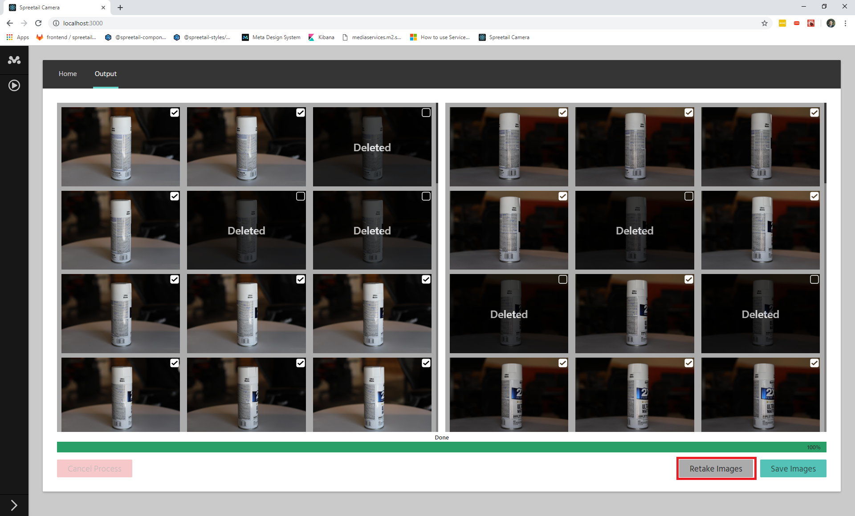

**Figure 11**

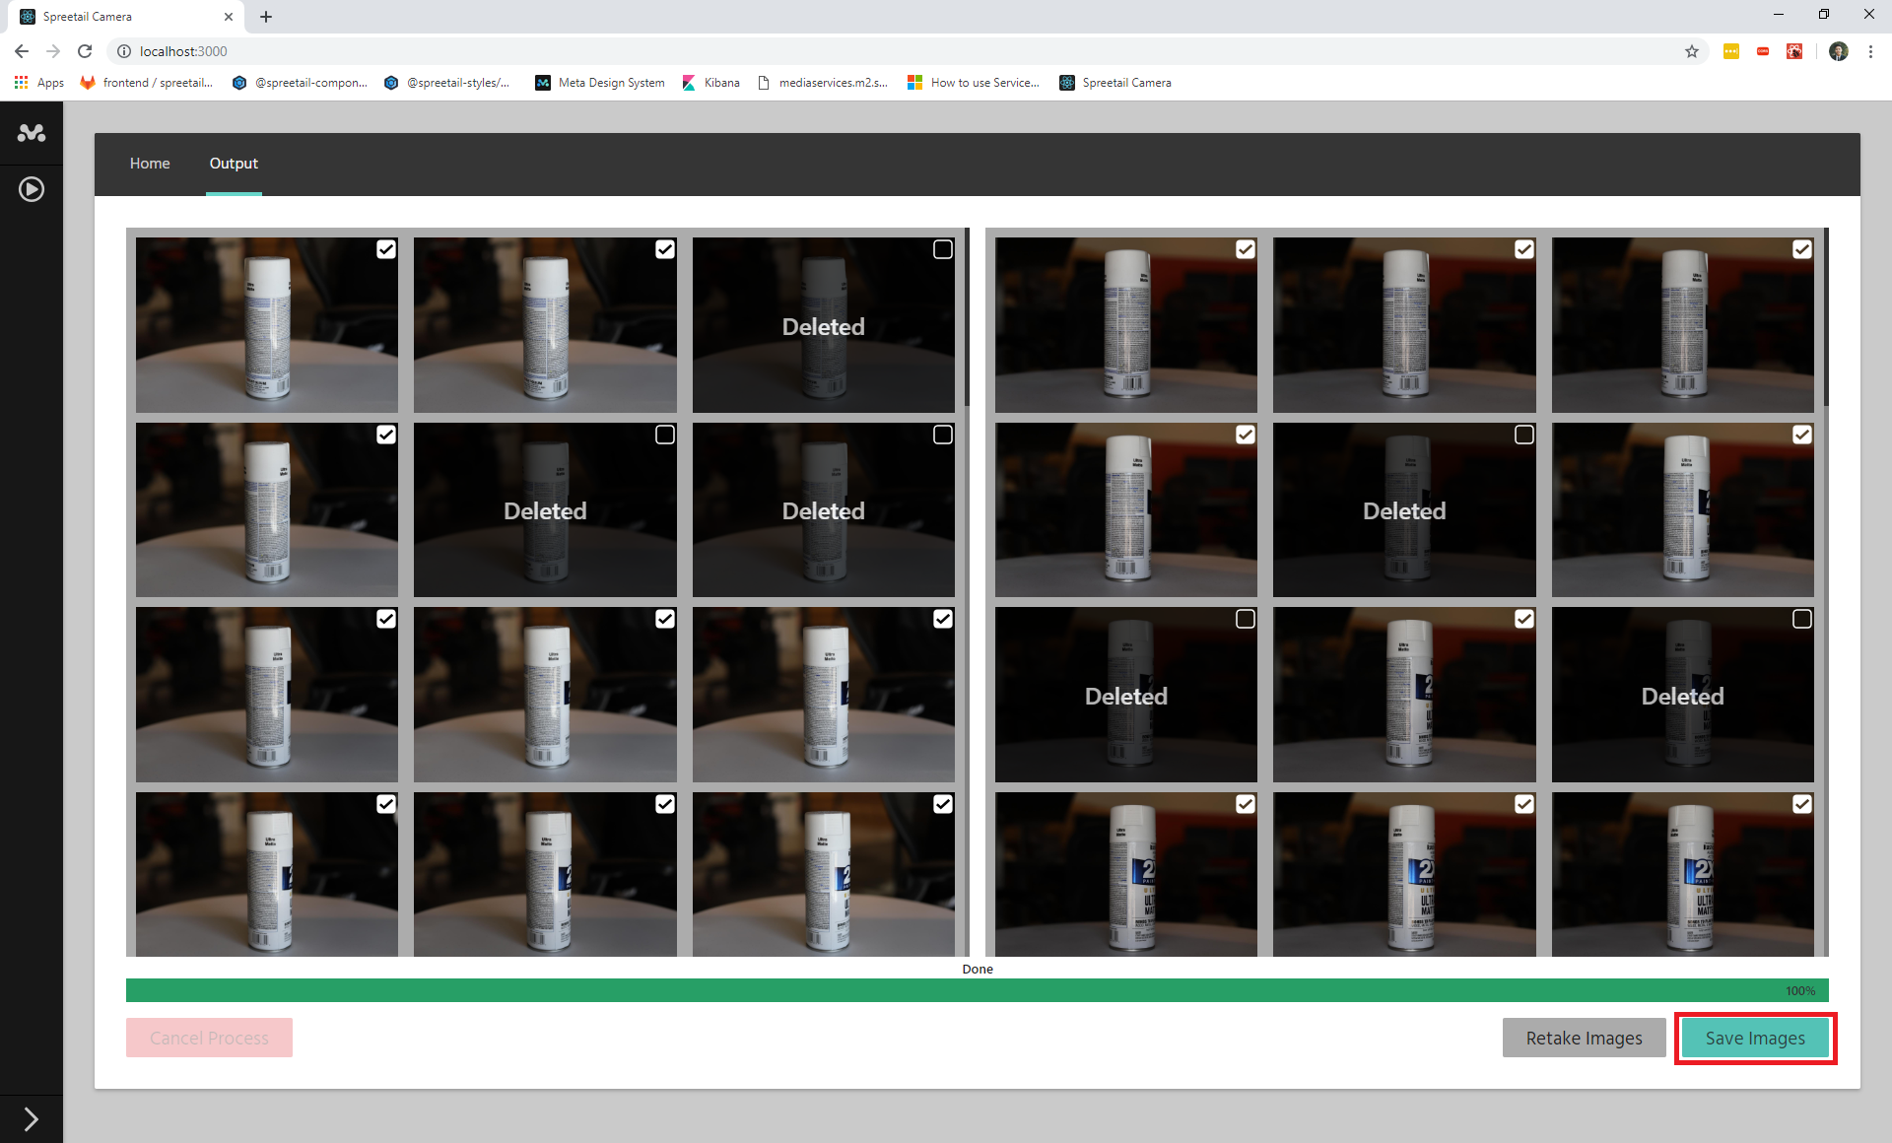

**Figure 12**

# Troubleshooting

This section contains the troubleshooting methods for common errors or issues encountered during the 360-degree photography process.

## Missing Camera Error

This error is thrown when the computer tower does not have 2 cameras connected via usb.

1. Make sure both cameras are plugged into power and turned on
2. Make sure both cameras are connected to computer tower via usb

## Autofocus Error

This common error is caused by a camera’s inability to auto-focus on the product. Sometimes the cameras can be bumped and the product is no longer in frame, or the lighting isn’t consistent and causes this error.

1. Make sure that the cameras are able to focus on the product before starting any preview or process.
2. Follow the Product and Camera Placement section.

## Camera Error

This encompases any errors that are not autofocus or missing camera errors. The simple fix for any “Camera Error” is to start the process over from the beginning. Resetting the products and camera angles should fix this error.

## Slow Camera Capture

This can be an issue with the communication between the cameras and the hardware tower. If the cameras are taking much longer than the provided interval to capture images, then try the steps below:

1. Unplug and plug in the usb cables from the hardware tower.
2. Turn the cameras off then on
3. Restart the hardware server